## Merchant Name: Aleph Labs Inc Implementation POC: Royce *(IM to fill)* CX POC: *[IMP to Add]*

### 

### 

| Notes Sections   *(AE to fill if they have, Implementation to be completion DRI on handoff)*   * Info on how merchant bills   + Seat based (within the contract it will state the seat cost)   + Yes and no to dynamically changing during the contract   + Customers have the option to add on seats a la carte via Stripe   + Flat Saas fee   1) What is the merchant temperament?  Both Augusto and Pablo are both sharp and easy going. Augusto will be leading the implementation. They are fairly easy to work with.  3) What are the Tabs features that the key POC cares about?   * Invoice generation * Dunning * Stripe integration * QB Integration * CashApp * Hubspot |
| --- |

### Billing model *(Entire Section: Implementation to fill section)*

* Are there unique things about the customer creation process for this merchant?
* Information on how merchant bills
* How contract is broken up
* One off things to know about the merchant

### Contract Processing Steps *(Entire Section: Implementation/Success to fill Post-Go Live)*

1. Steps to process

Customer Assignment

* Use the customer noted in the **pdf file name**
* Example below - contract has “Last Brand Inc” as the customer but file name says “Quince”
  + Use “Quince”
* If no customer noted in file name, use the customer noted in the contract

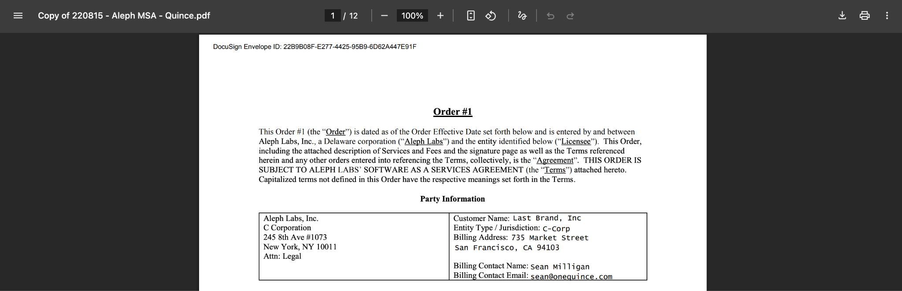

Locate Billing Terms

* Each item listed under subscription, user, or integration fees should be a separate BT
* Fee table typically on the first page

1. Item Name
   1. Use the item label exactly as shown in the "Fees & Users" or similar table
   2. Examples: "Integration Fees", "Additional User Fee"
      1. EXCEPT “Subscription Fee” should **always** be named “Base Fee”
2. Quantity
   1. Use the quantity listed in the contract if applicable
   2. If no quantity is listed, default to 1
3. Total Price
   1. Use the full amount listed for each line item
   2. For Additional User Fees, use the price per unit for the individual billing period
      1. Do not create tiered unit BT - even if there is a number of users included in the subscription/base fee product
         1. Merchant will track this individually on their end
   3. For one-time fees (e.g., Integration Fee), use listed total
4. Service Start Date
   1. Use the "Order Effective Date" unless another specific date is provided
      1. If not in the table, reference first paragraph
5. Months of Service
   1. Use the "Initial Term" length stated in the contract
      1. Also use this for implementation fees
   2. Default 12 if not stated
6. Billing Start Date
   1. Match Service Start Date unless a different start date is clearly stated
7. Period
   1. Number of periods that need to be billed for based on the frequency and term
      1. E.g. if the term is 12 and frequency is quarterly, you have to bill 4 times so period = 4
8. Frequency
   1. Determine frequency based on pricing language:
      1. If stated as "$X per month" → Monthly
      2. If stated as "$X per year" or annual total → Annual
      3. One-time fees like integration should have Frequency = None
9. Billing Timing
   1. For flat fee - bill first of period
   2. For unit price - billed in arrears
10. Net Terms
    1. Look for net terms in the payment and fees section
       1. Sometimes noted on the first page; can also check “payment timing” or “fees” section
    2. If not stated, default to Net 30
11. Integration Item
    1. TBD
12. Ignore
    1. Do not create BTs for $0 items unless clearly labeled as waived or discounted
    2. Ignore general descriptions of services, platform features, or SLAs unless tied to a billable line item
13. Example contracts

8380f4e1-6f7a-411d-95f1-6d28ff7c58ba

9fe22ff3-201e-4e32-8fd2-6bd2d4f7c8f5

009ef9b0-0acb-45d8-97f7-ec503f2125ab

1. Anything to ignore in contracts?
2. Specifics processing things the merchant has requested that may differ by contract (e.g. always back-date invoice date to final day of the month)
3. Default Service Term
   1. If None Listed, Ops Default is 1 Year
4. Default Net Payment Terms
   1. If None, Ops Default is 0
5. Default Billing Frequency
   1. If None Listed, Ops Default is Monthly
6. How do we handle taxes as a line item?
   1. If None Listed, Ops Default is every tax line item becomes a BT

### Events Processing (if necessary) *(Entire Section: Implementation/Success to fill Post-Go Live)*

* Any important information on events billing

Integration Items Processing (if necessary)  
*(Entire Section: Implementation/Success to fill Post-Go Live)*

* What are the instructions for assigning integration items?
* Example: All Statsig integrations items should be labeled as “Sales”
* Example: All “Pinata” integration items should be labeled as “Software Subscription Bundle” unless otherwise noted by Merchant

Post Processing Communications (if necessary)  
*(Entire Section: Implementation/Success to fill Post-Go Live)*

* Does the Ops Team need to notify anyone on the team re: completion of processing batches in Implementation or Active phase?
* Who needs to be notified and when?
  + Example:
    - Who: Customer Success [Azmat Aziz] needs to be notified
    - Where: Messari internal merchant channel
    - When: contracts are processed [Merchant Phase: Active]

### Customer Information *(Entire Section: Implementation/Success to fill Post-Go Live)*

* Any important information on specifics customers of this merchant
  + Special memo’s certain invoices require
  + Invoice changes due to merchant/customer relationship

### Feature Requests *(AE to fill for all requests prior to Imp handoff, Imp to fill prior to go-live/Success to fill to fill Post-Go Live)*

* API integration between Aleph and Tabs
  + Integration between Tabs and the Aleph software
  + Aleph is an FP&A software so it is important for their reporting
  + Medium, I do not anticipate them asking for/needing this immediately but soon into the relationship

### Merchant Calls *(AE to fill for all videos prior to Imp involvement, Imp to fill prior to go-live/Success to fill to fill Post-Go Live)*

* Will need to sync with Rebecca and the calls are currently private and in her name
* .
* .